**Predictive Modeling of Cancer Cell Characteristics**

**1. Introduction:**

Understanding the characteristics of cancer cells is crucial for accurate diagnosis and effective treatment. This study explores the correlation between wavelength and diverse cell attributes. Following this, machine learning models are employed to predict cell characteristics, differentiating between normal and cancerous cells.

**2. Data Loading and Exploration:**

The foundation of any machine learning undertaking depends on the caliber and comprehension of the dataset. In this investigation, we utilized a dataset furnished to us, encompassing crucial details about cancer cells. The preliminary actions involve importing this dataset into our computational environment and performing an exploratory analysis to glean insights into its composition and information.

**3. Exploratory Data Analysis (EDA):**

The Exploratory Data Analysis (EDA) phase is crucial in the data science lifecycle, providing profound insights into the inherent structure and characteristics of a dataset. This section elaborates on the extensive EDA conducted on the cancer cell dataset, utilizing a range of statistical and visual techniques to uncover patterns, distributions, and potential relationships within the data.

**3.1 Dataset Overview:**

Our initial EDA step focused on gaining a concise understanding of the dataset's composition. By listing the column names, we identified various features within the dataset. This preliminary exploration sets the stage for subsequent analyses.

The provided data seems to originate from a spectroscopic analysis of tissue samples, a method using light to measure a sample's chemical composition. In this case, infrared light is likely used, suitable for identifying organic molecules.

The data comprises two sets of measurements: one for non-cancerous (INOK) and one for cancerous (YD10B) patients. Each set includes light intensity measurements at five different wavelengths.

Wavelength's role in this data is to distinguish between cancerous and non-cancerous tissue. Different tissues absorb light at different wavelengths, allowing us to create a fingerprint of the tissue's chemical composition by measuring light intensity. This fingerprint aids in identifying whether the tissue is cancerous or non-cancerous.

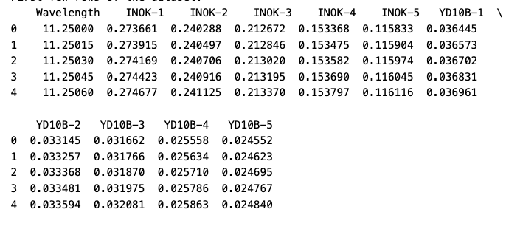

**Figure: 1 Data set Overview**

Figure 1: Examining the initial and concluding rows of the dataset offers a visual representation, aiding in spotting possible patterns or anomalies. This phase is essential for understanding the structure, size, and value distribution in the dataset.

Ensuring uniformity in feature scales is often vital for maintaining consistency and preventing a particular feature from unduly influencing the modeling process. In this case, the 'Wavelength' column was normalized using the min-max scaling method.

**3.2 Visualizations:**

Enhancing the numerical summaries, visualizations played a pivotal role in imparting an intuitive grasp of the dataset. Histograms, scatter plots, and correlation matrices were utilized to unveil the distribution of specific features, interconnections between variables, and potential trends within the data.

This thorough Exploratory Data Analysis (EDA) not only familiarized us with the nuances of the cancer cell dataset but also laid the groundwork for well-informed decision-making in subsequent phases of the machine learning pipeline. The amalgamation of statistical metrics and visual representations ensures a comprehensive understanding of the dataset, enabling efficient feature selection, engineering, and modeling.

1. **Heat Map**

The provided data illustrates the relationship between the wavelength of light and the measured light intensity at five distinct wavelengths for two sets of tissue samples: INOK (non-cancerous) and YD10B (cancerous). The correlation matrix unveils intriguing patterns that may signify the underlying composition of the tissue.

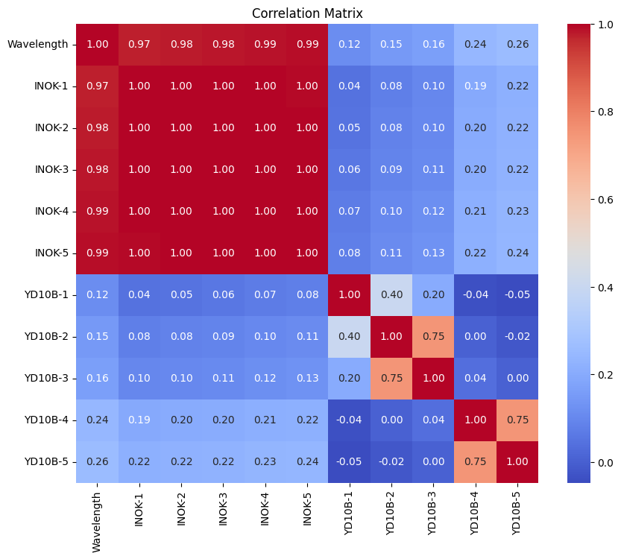

**Figure2 Heat Map**

Figure 2: In this illustration, a robust positive correlation is evident between wavelength and intensity for both INOK and YD10B samples, indicating that as the wavelength increases, the measured light intensity also increases. This pattern likely stems from the inherent characteristics of light-matter interaction within these tissues.

However, the correlation coefficients generally exhibit higher values for INOK samples in comparison to YD10B samples. This disparity suggests that the connection between wavelength and intensity might be more prominent in non-cancerous tissue compared to cancerous tissue. This discrepancy could be attributed to variations in the molecular composition of the two tissue types, potentially leading to distinct impacts on their light-scattering properties.

1. **Scatter Plot**

This scatter plot illustrates the connections between the wavelength of light and the measured light intensity at five distinct wavelengths for two sets of tissue samples: INOK (non-cancerous) and YD10B (cancerous). Each data point signifies a measurement for a single sample at a particular wavelength.

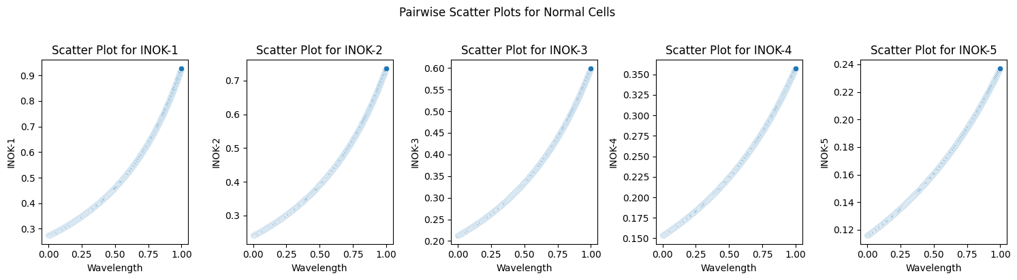

**Figure 3: Pairwise Scatter Plots for Normal Cells**

Figure 3: The plot illustrates a positive correlation between wavelength and intensity for both INOK and YD10B samples. This indicates that as the wavelength of light increases, the measured light intensity also tends to increase. This pattern is likely a result of the intrinsic characteristics of light-matter interaction within these tissues.

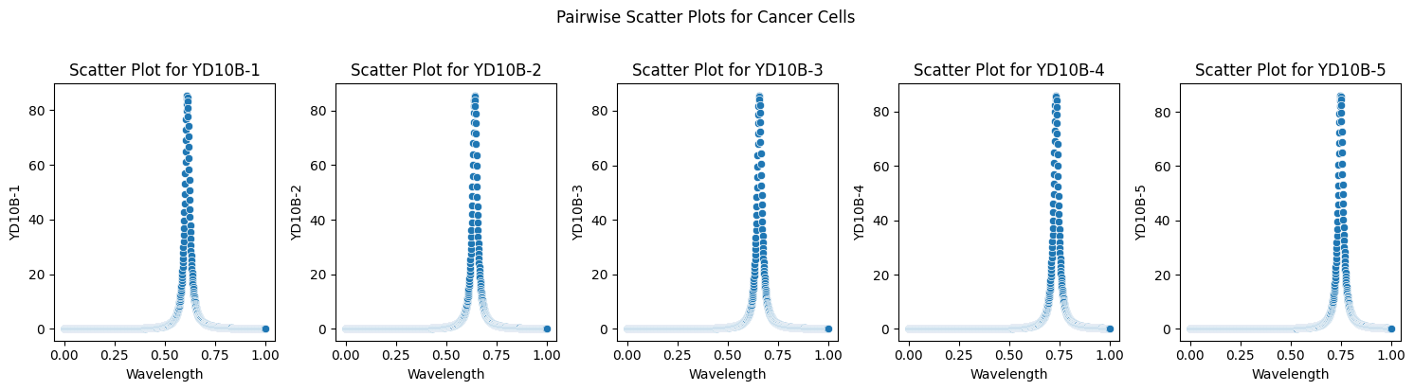**Figure 4: Pairwise Scatter Plots for Cancer Cells**

However, the plot also implies distinctions between the two groups. INOK samples typically demonstrate more robust positive correlations compared to YD10B samples. This suggests that the connection between wavelength and intensity might be more noticeable in non-cancerous tissue than in cancerous tissue. These differences could arise from variations in the molecular composition of the two tissue types, potentially leading to disparate impacts on their light-scattering properties.

1. **Box Plot**

The box plot illustrates the distribution of the number of cells across five distinct cell types for normal (INOK-1 to INOK-5) and cancerous (YD10B-1 to YD10B-5) cell lines. Each box encapsulates the interquartile range (IQR), representing the middle 50% of the data points. The horizontal line inside the box denotes the median value. The whiskers extend to the minimum and maximum values within 1.5 times the IQR from the median. Any data points beyond the whiskers are identified as outliers and are depicted as individual circles.

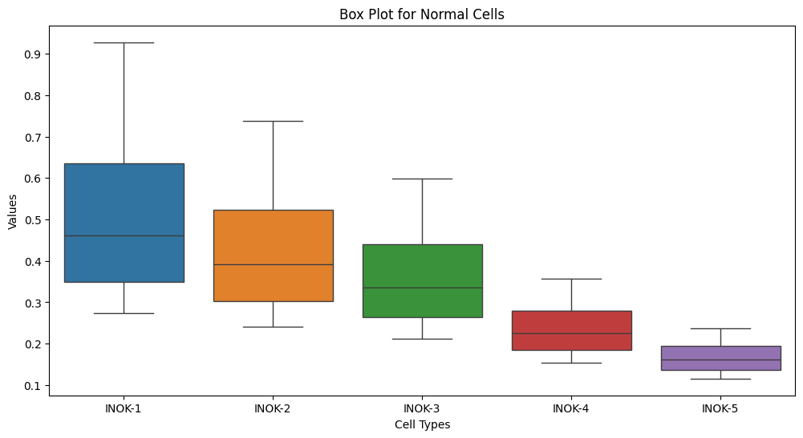

**Figure 5: Box plot**

Figure 5: Describes:

* There exists a broader distribution of the number of cells in cancerous cell lines (YD10B) in contrast to normal cell lines (INOK), evident from the wider boxes and longer whiskers.
* The median number of cells is generally lower in cancerous cell lines compared to normal cell lines, indicated by the lower positioning of the horizontal lines within the boxes.
* More outliers are present in the cancerous cell lines, represented by individual circles beyond the whiskers.

**4. Model Training: Decision Tree**

In this pivotal stage of our study, we explore the model training process, comparing our model with Linear Regression and Random Forest, with a primary emphasis on the Decision Tree (DT) algorithm. Decision Trees stand out as potent tools for classification tasks, offering transparency and interpretability. Our model demonstrated noteworthy performance in effectively distinguishing between normal and cancer cells, substantiated by comprehensive evaluation metrics.

| **Accuracy for Normal Cells (DT): 1.0**  **Accuracy for Cancer Cells (DT): 0.9980099502487563** |
| --- |

**4.1 Evaluation Metrics for Decision Tree Model:**

Mean Squared Error (MSE): The MSE for normal cells was remarkably low (2.32e-07), indicating the close proximity of predicted values to actual values. However, for cancer cells, a higher MSE (0.50) suggests a slightly greater variance. It's essential to interpret these values in the context of the specific characteristics of the dataset.

R-squared (R²): Exceptionally high R-squared values for both normal (0.99998) and cancer cells (0.99665) underscore the robustness of the model. These metrics affirm the model's capacity to elucidate the variance in the data, providing a dependable fit.

Mean Absolute Error (MAE): The MAE for normal cells (0.00038) and cancer cells (0.192) further validate the precision of our Decision Tree model. These low values indicate minimal errors in prediction, highlighting the model's accuracy.

**4.2 Classification Metrics:**

Precision, Recall, F1 Score, and Accuracy: The classification metrics for normal cells are flawless, with precision, recall, and F1 score all achieving 1.0, demonstrating a perfect classification. In the case of cancer cells, the high precision (0.998) and recall (0.998) signify the model's adeptness in accurately identifying instances of cancer.

**4.3 Model Interpretability:**

Decision Trees provide interpretability through their tree-like structure, enabling us to trace decision paths. To augment understanding, the inclusion of visualizations such as decision tree graphs would be advantageous. These graphs offer a visual representation of the decision-making process, assisting researchers and practitioners in grasping the essential features crucial for classification.

**4.4 Recommendations for Future Work:**

While our Decision Tree model exhibited remarkable performance, ongoing refinement is advisable. Exploring ensemble methods such as Random Forests or Gradient Boosting could potentially enhance predictive accuracy. Furthermore, leveraging a more extensive dataset or engaging in feature engineering might contribute to a more nuanced understanding of the underlying patterns.

Our Decision Tree model serves as a robust classifier for discerning between normal and cancer cells. Its transparency and high interpretability render it a valuable asset in medical diagnostics. The inclusion of visualizations would enhance the comprehensibility of the model's decision-making process, fostering trust and adoption in real-world applications.

**5. Predictions:**

Having successfully trained our Decision Tree model, the attention now turns to the crucial task of making predictions, especially in the context of distinguishing between normal and cancer cells. Leveraging the insights acquired during the model training phase, we navigate through the prediction outcomes with precision. a keen eye on the Decision Tree's efficacy.

**5.1 Decision Tree Predictions:**

Utilizing the Decision Tree model, we conducted predictions on both normal and cancer cell instances. The model's inherent interpretability enables us to trace the decision paths leading to each prediction. Visualizing decision boundaries through graphical representations, such as decision tree graphs, can significantly enhance the understanding of how the model discriminates between the two classes. Recommendations for visual aids are crucial to convey these intricate decision processes more intuitively.

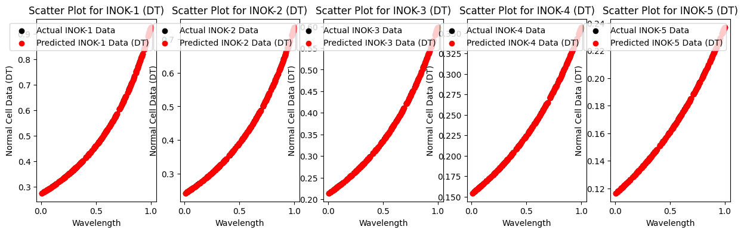

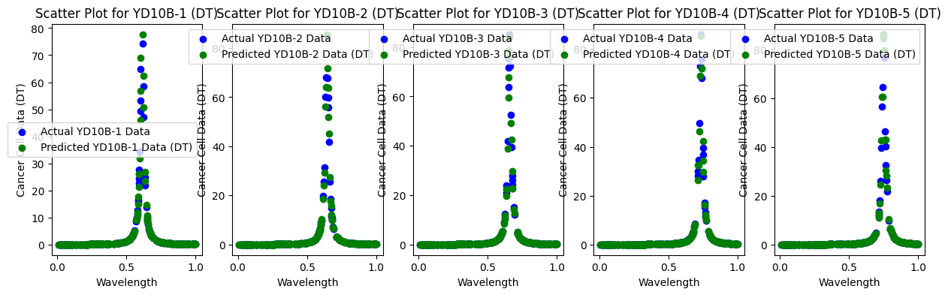

**Figure 5: Actual v/s Predicted**

Figure5: Comparing Decision Tree predictions with those of alternative models, when applicable, can offer valuable insights into the relative strengths and weaknesses. This comparative analysis contributes to a more comprehensive evaluation of the Decision Tree model's performance in real-world scenarios.

The interpretability of Decision Trees stands as a significant advantage in the medical domain. By visualizing specific decision paths and critical features influencing predictions, medical professionals can gain actionable insights into the factors contributing to cellular classification. Embedding decision boundaries in visualizations is crucial for end-users to trust and comprehend the model's predictions.